Thomas Courtney

3175353  UON

PHYS2170: Quantum Mechanics Simulation



Contents

Abstract 2

Introduction 2

Discussion 4

Part One – Quantum Mechanical Time Development 4

Part Two – One Dimensional Bound State Problems 6

Part Three – Normalization and Expectation Values in a Finite Square Well 8

Part Four – Stationary States in One Dimension 10

4.1 Step Potential 10

4.2 Square Barrier 11

Conclusion 12

Bibliography 13

# Abstract

This report details observable quantum mechanical phenomena demonstrated using simulation software. The phenomena include Heisenberg’s Uncertainty Principle, quantum probability distributions and expectation values of observables and quantum tunnelling. It was shown that gaussian and Lorentzian wave packets obeyed Heisenberg’s Uncertainty principle and that expectation values are useful in determining the predicted behaviour of quantum system’s. By increasing the energy of an incident particle on a potential barrier, reducing the barriers potential energy or reducing the width of the barrier the transmission of the incident particle will increase. Classically no penetration would be observed at the barrier.

# Introduction

The physical world consists of quantum and classical systems. Classical systems are large and exhibit behaviours that are easily observable. For example, a car driving down the street or the moon orbiting the Earth. Quantum systems are small and more difficult to observe. They are so small that our tool for observing them, light, changes their state, for this reason we cannot measure a quantum system’s observables simultaneously. “Observables” include momentum, position and energy of a quantum system. An example of a quantum system is an electron accelerating in an electric field. If we tried to observe this particle’s position and momentum simultaneously the light used to do so would change its state (an exception to this property is if we are able to “commute” the operators of an observable). This property is described by Heisenberg’s Uncertainty Principle (*see equation 1).*

$$Equation 1: ∆ⲣ∆x≥ħ$$

This relationship states that the uncertainty in the position of a particle in a quantum system is related to the uncertainty in the particle’s momentum proportional to Planck’s constant divided by 2π. This principle is important in determining the probability of observing a quantum particle in a certain state.

A quantum particle’s probability distribution of appearing in a location at a given moment is described by a wavefunction (Ψ (x, t)) [1]. The reason we can use a wavefunction to describe a particle is because in quantum system’s particles exhibit a wave-particle duality (as demonstrated by the photoelectric effect and double slit experiment). Schrodinger’s equation describes the behaviour of a quantum particle (*see equation 2*).

$Equation 2: +Ψ(x,t)V\left(x,t\right)$

This equation is may be used to find the quantised (allowed) energy states of a quantum particle. The solution to the equation is a wavefunction that is based on Fourier’s method of Eigen Values. This method substitutes the wavefunction for an infinite series of other periodic functions [1]. Schrodinger’s equation is useful because it can be used to deal with the problems of the atomic structure of matter.

# Discussion

## Part One – Quantum Mechanical Time Development

Schrodinger’s equation allows the mathematical modelling of quantum system’s. Implementing of the mathematics in software allows the simulation of quantum systems. Simulation software helps to demonstrate quantum phenomena and the interaction between a quantum system’s parameters. For example, we may observe the effect of changing the position uncertainty in a system, the system’s momentum uncertainty (dictated by equation 1). Furthermore, we can see this effect over time.

A quantum system may consist of a superposition of many quantum states. In a simulation of a quantum system we see over time that the momentum probability distribution spreads out and moves to the right. The distribution moves toward the right as the majority of the quantum system’s constituent quantum states have a positive momentum. The reason the distribution spreads out over time is because of the difference in the different component momentum’s.

This demonstrates that a quantum system’s probability distribution of position and momentum evolve over time and are hence time dependent. This simulation was modelling a Gaussian (ideal) wave packet. Additionally, the values provided by the simulation for uncertainty in position ($∆x$) and uncertainty in momentum ($∆ⲣ$) confirmed Heisenberg’s Uncertainty Principle (Equation 1) for a gaussian wavefunction. The effect of equation 1 can be seen if the uncertainty in position is halved as we see a doubling in the width of the momentum distribution wavefunction. This means that more “off-peak” values contribute more to the wavefunction’s evolution over time and we see a more rapid spreading out of the momentum distribution over time (see figure 1). That is, when the momentum’s uncertainty was less there was a greater concentration of momentum values which means the system’s momentum value was in a smaller range.

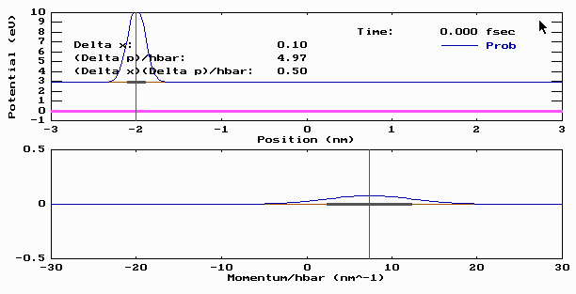

Figure : Probability distribution over time

This simulation demonstrates that when measuring quantum system’s, it creates an uncertainty in what we observe, this is different to classical systems where any measurement taken is “gentle” as it doesn’t alter the state of the system being observed.

## Part Two – One Dimensional Bound State Problems

When a particle experiences a potential energy, this potential energy, like gravity holding a ball at the base of a valley, holds the particle. The particle may escape if its own energy (kinetic energy) is greater than that of the potential holding it, for example if the ball were fired out of a canon it could leave the valley. This potential energy may be modelled as a quantum well. A hydrogen atom may be modelled as a quantum well, where the electron orbiting the nucleus is the ball in the valley. The electron is held orbiting the nucleus of the atom at a certain radius. This radius is associated with its energy and quantum number(n). Should the electron acquire greater energy it may increase its radius.

The simulation software used however shows that only certain energy levels (radii) are allowed. We know this as the wavefunction (probability distribution) of an *allowable* energy level will decay to zero where the particle is found outside of the well with less energy than the well (see Figure 2).

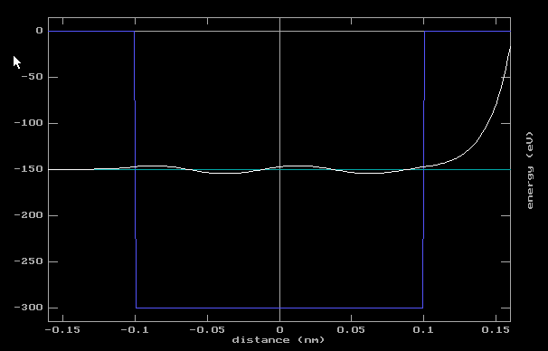

Figure 2: Finite Square Well- disallowed energy level.

The wavefunction in figure two does not decay outside the well when it has less energy than the potential acting on it. This demonstrates that not all energy levels are allowable in a quantum system, this is called “quantisation” of a property. That is, energy in a quantum system is quantised.

The “finite well” in figure two gave 6 allowable energy levels up to 300ev from 0ev (see table 1).

|  |  |
| --- | --- |
| **Quantum Number** | **Energy (eV)** |
| 1 | 7.59 |
| 2 | 30.28 |
| 3 | 67.8 |
| 4 | 119.56 |
| 5 | 184.33 |
| 6 | 258.57 |

*Table 1: Allowed Energy levels in a quantum well.*

The same energy levels calculated for an “infinite quantum well” were larger than those for the finite well.

The expectation values (average value) for the positions of the particle at energy levels n=1, 4, 6 differs. At E1 the expectation value is the centre of the well, for E4 and E6 the expectation value is at the troughs and peaks and the waveforms probability distribution.

A particle in a *finite* quantum may be found outside of the well though the probability is small, and the probability will rapidly decay to zero. In an infinite at the boundaries of the well and outside the well the probability of finding the particle is zero.

## Part Three – Normalization and Expectation Values in a Finite Square Well

Normalization is performed on quantum wavefunctions so that all probabilities add to one. The reason is so that probabilistic description of the wavefunctions only makes sense when their probabilities sum to one [2]. The expectation value of an observable is its average value.

We may use simulations to calculate the expectation and probability distribution of observables in a quantum system.

The expectation value of a particle’s observable is calculated:

$$Equation 3: <E>= ∫ψ^{*}ψ dx$$

In a 300eV quantum well for a particle at E1 the simulation demonstrated that the probability of finding the particle at this energy was 1, or certain.

When integrating for position the simulation returned an expectation value of 0. This means the particle most likely found at equilibrium. Increasing the energy level of the particle continued to return an expectation value of 0, the reason for this is as the wavefunctions are symmetric sinusoids which when integrated, will mathematically, result in zero. Physically this represents a particle that is most likely to be found at equilibrium.

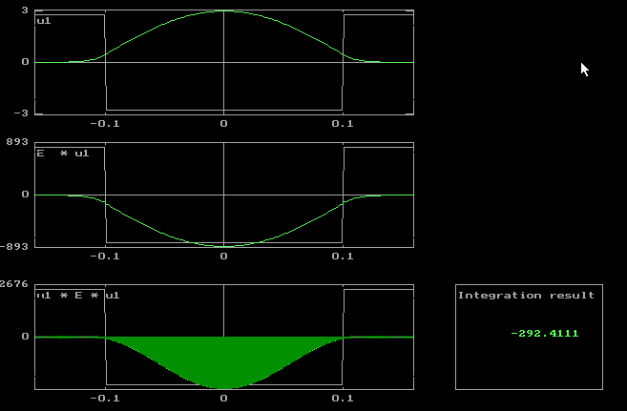

Figure 3: Energy expectation value of allowed energy level

The expectation values for potential energy and total energy were observed to be -299.2234eV and -292.41eV respectively (see figure 2). Kinetic, potential and total energy are related by,

$$E=T+V$$

hence the expectation value for the kinetic energy is 6.81eV.

Kinetic energy may be represented as $\frac{p^{2}}{2m}$. Using the expectation value of $p^{2}$ the expression may be calculated. It was found that $\frac{p^{2}}{2m}$ was equivalent to the operator for kinetic energy. In doing so it was found that the expectation value of kinetic energy was 6.81eV. This is consistent with the kinetic energy calculated using the total and potential energy values.

## Part Four – Stationary States in One Dimension

### 4.1 Step Potential

A stationary state is a purely quantum mechanical state that is independent of time. It describes a particle “free particle”. The reason it is time independent is as it’s had no force acting on it due to a potential energy field (“free). Its observables may hence be determined disregarding time.

Like a quantum well, a “potential energy step” exerts a force upon particle’s interacting with it that hence alter that particle’s observables. This was demonstrated via simulations (see figure 3).

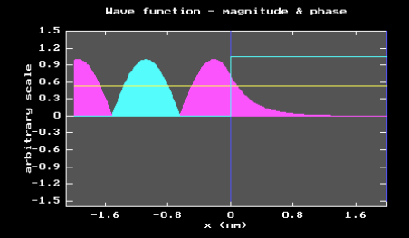

Figure 4: Particle interaction with step potential

The different colours indicate the parts of the waveform are out of phase 180 degrees (mauve is negative). The waveform rapidly decays upon striking the potential well, this is because the particle’s energy is lower than the well so it’s probability of penetration and continued propagation is very low. The further the particle travels past the barrier the lower the probability.

The sinusoids wavelength in this simulation is approximately 1.6nm.

Upon halving the particles energy its wavelength is approximately 2nm

The rapid decay of the particle past the barrier is exponential in shape. The penetration can be seen reflected in the wavefunctions value, were the energy of the particle higher or potential of the barrier it may penetrate further. Classically you would see no penetration (“tunnelling”) and the particle would be entirely reflected.

### 4.2 Square Barrier

A “square barrier” is a lot alike a potential well but upside down. The reflection and transmission (penetration) of a particle interacting a barrier are quantified in the parameters R and T. By altering the width of the barrier, the barrier’s potential and the energy of the particle R and T will be affected.

R and T are related:

$$R+T=1$$

By halving the potential energy of the barrier, the transmission increases, and reflection decreases as observed in the simulation (see table 2).

|  |  |  |
| --- | --- | --- |
| **Barrier Potential (eV)** | **Reflection** | **Transmission** |
| 1 | 0.9971 | 0.0029 |
| 0.5 | 0.9624 | 0.0376 |

*Table 2: Reflection and Transmission of particle interacting with square barrier.*

These results reflect what is generally the case for a quantum tunnelling and that is that transmission is approximately zero and reflection is approximately 1 (see figure 5).

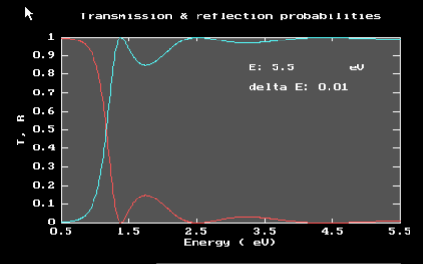

Figure 5: Reflection and transmission of particle striking potential barrier

Similarly, the particle transmission will increase with its energy. The determining for transmission is the particle’s energy relative to the barrier not the particles absolute energy.

# Conclusion

Using simulation software, several principles and phenomena observed in quantum systems were verified. Gaussian and Lorentzian wave packets were shown to obey Heisenberg’s Uncertainty Principle. Particle’s in both finite and infinite quantum wells demonstrated quantized energy levels that were lower in finite wells. Additionally, it was shown that expectation values are a powerful tool in predicting the behaviour of quantum particles in finite square wells. Finally, the interactions of stationary states with step potentials and square barriers were observed. By increasing the energy of the incident particle, reducing the width of the barrier or decreasing the barrier’s energy level transmission was increased. Transmission was very close to 0 and reflection very close to 1. In a classical system no transmission would be observed.

# Bibliography

|  |  |
| --- | --- |
| [1] | P. T. P. (. Ian Taylor, “What is the Schrodinger Equation?,” Physlink, [Online]. Available: http://www.physlink.com/Education/Askexperts/ae329.cfm. [Accessed March 2018]. |
| [2] | P. G. S. a. I. B. Vaibhav Sharma, “Quora,” [Online]. Available: https://www.quora.com/What-is-the-meaning-of-normalization-in-quantum-mechanics. [Accessed March 2018]. |